KUBERNETES TASK 10

Setup Eks Cluster Using Eksctl
. Setup eks cluster using eksctl Download this from browser and install in windows machine. • https://awscli.amazonaws.com/AWSCLIV2.msi
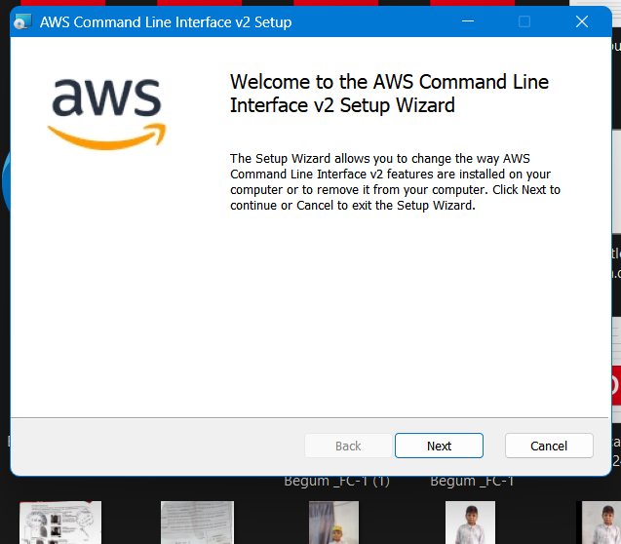
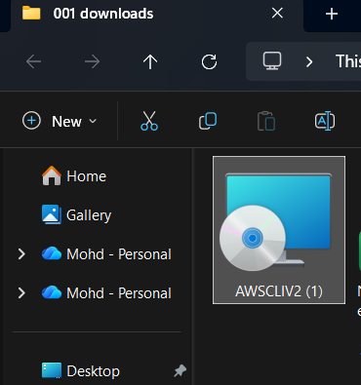

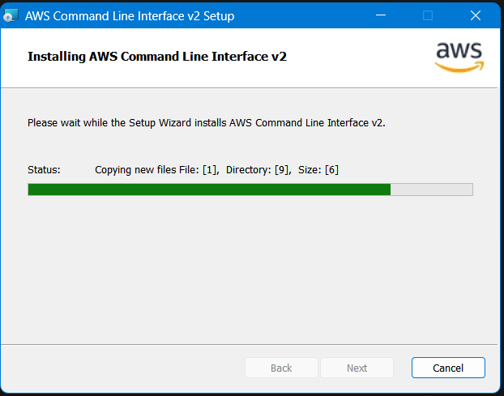
# aws –version
# aws configure
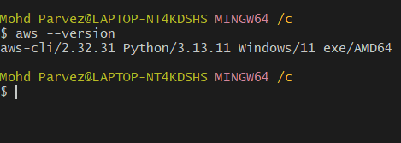
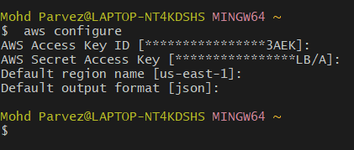
Download kubectl:
# curl -LO https://dl.k8s.io/release/v1.29.0/bin/windows/amd64/kubectl.exe
# mkdir -p ~/bin
# mv kubectl.exe ~/bin
# echo 'export PATH=$PATH:$HOME/bin' >> ~/.bashrc
# source ~/.bashrc
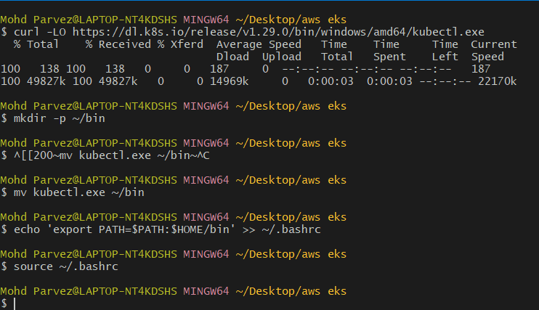
Download eksctl:
- curl -LO https://github.com/weaveworks/eksctl/releases/latest/download/eksctl_Windows_amd64.zip
- unzip eksctl_Windows_amd64.zip
- mkdir -p ~/bin
- mv eksctl.exe ~/bin
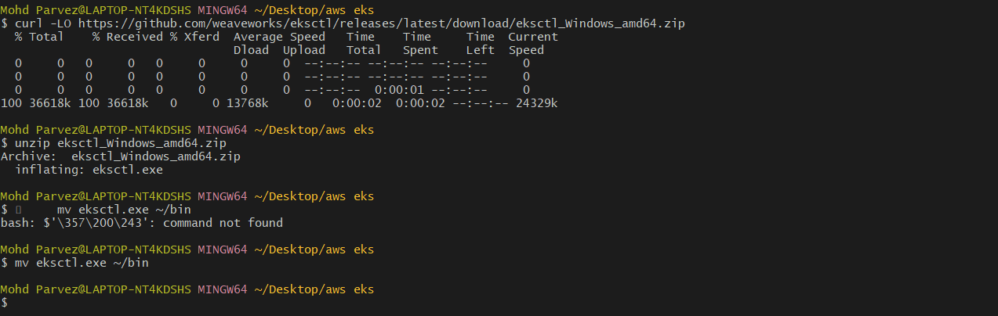
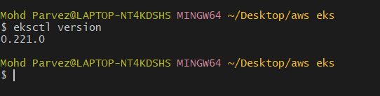
- eksctl create cluster \
--name my-eks-cluster \
--region us-east-1 \
--node-type c7i-flex.large \
--nodes 2
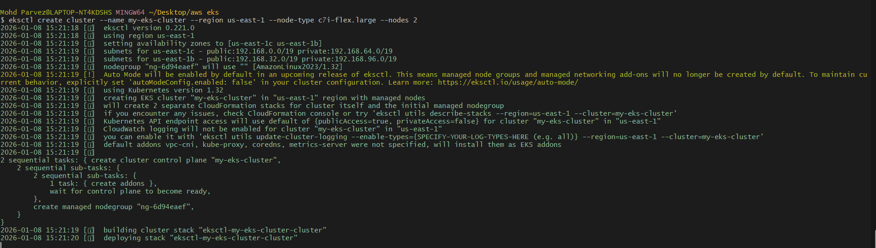
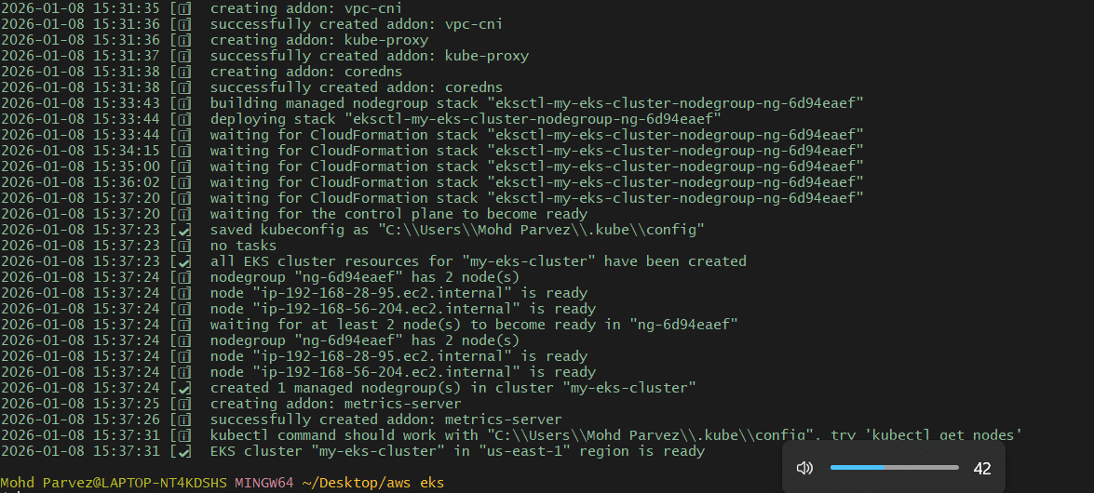

# kubectl get nodes
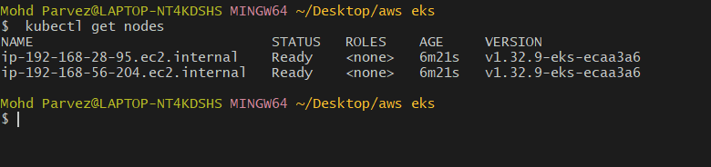
# kubectl get pods -A
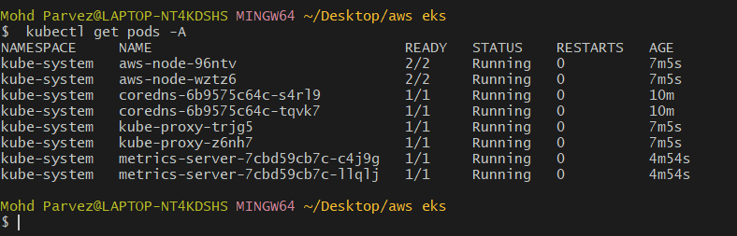
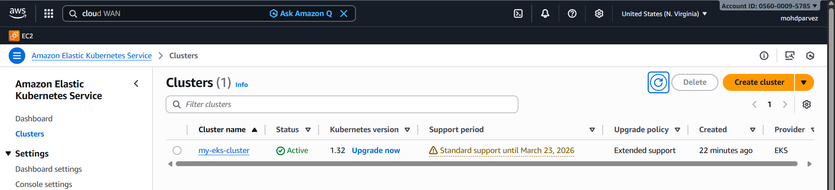
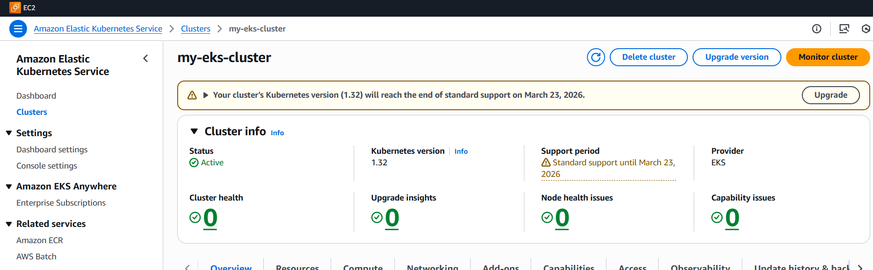

Setup Eks Cluster Using Console
Create an IAM Role for EKS Cluster.
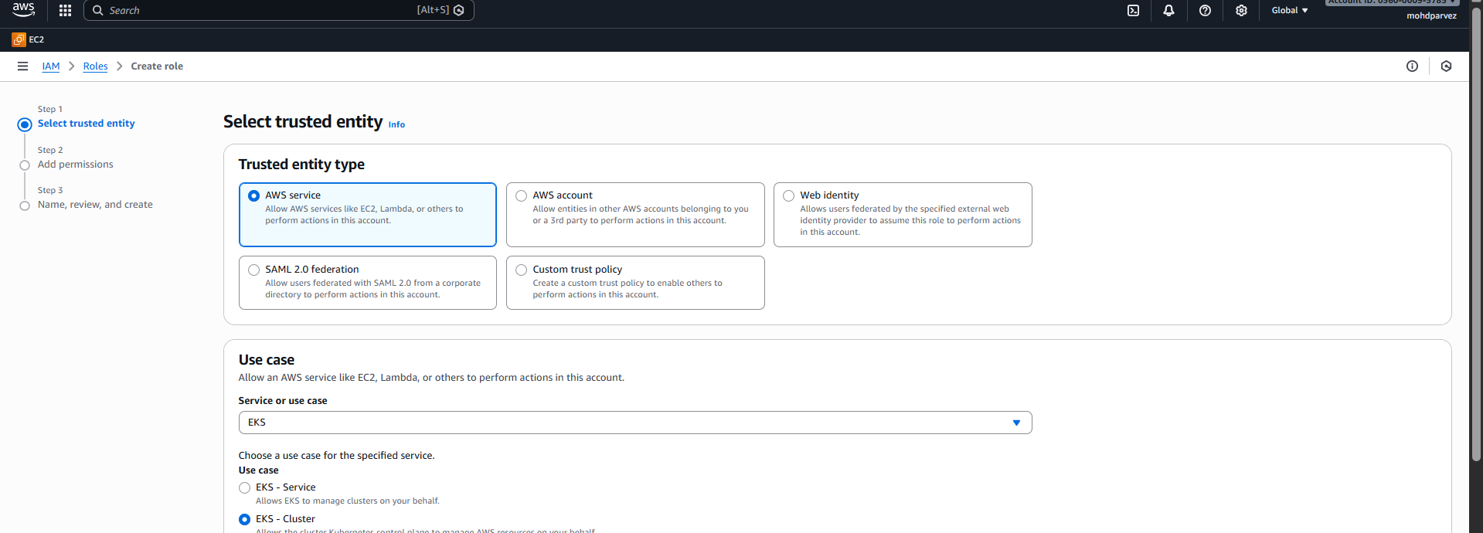

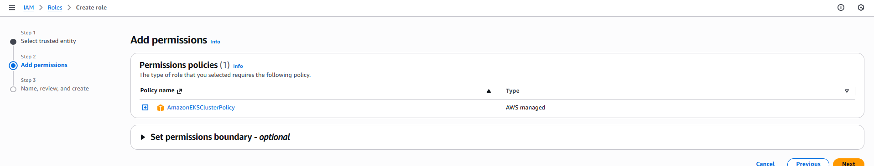
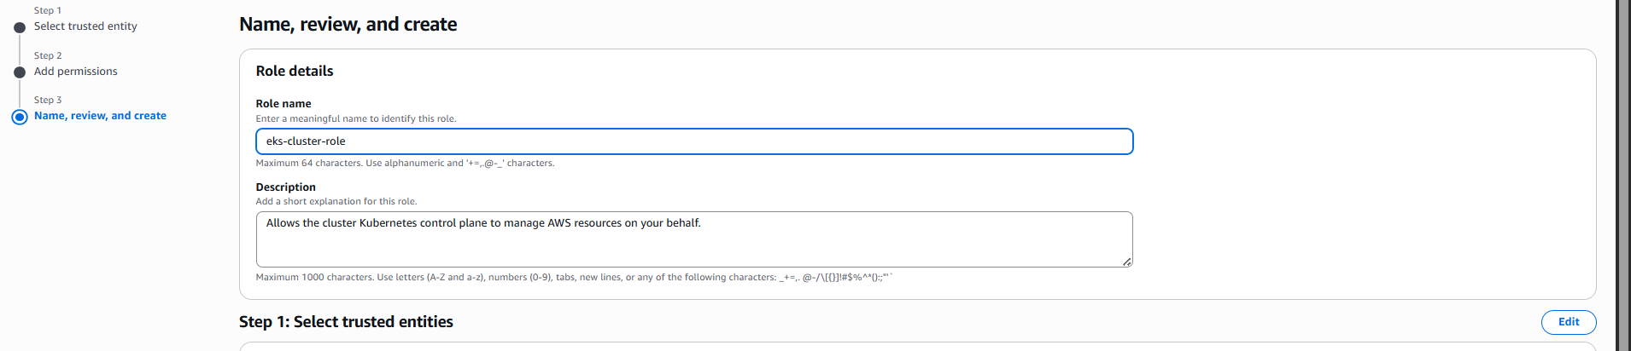
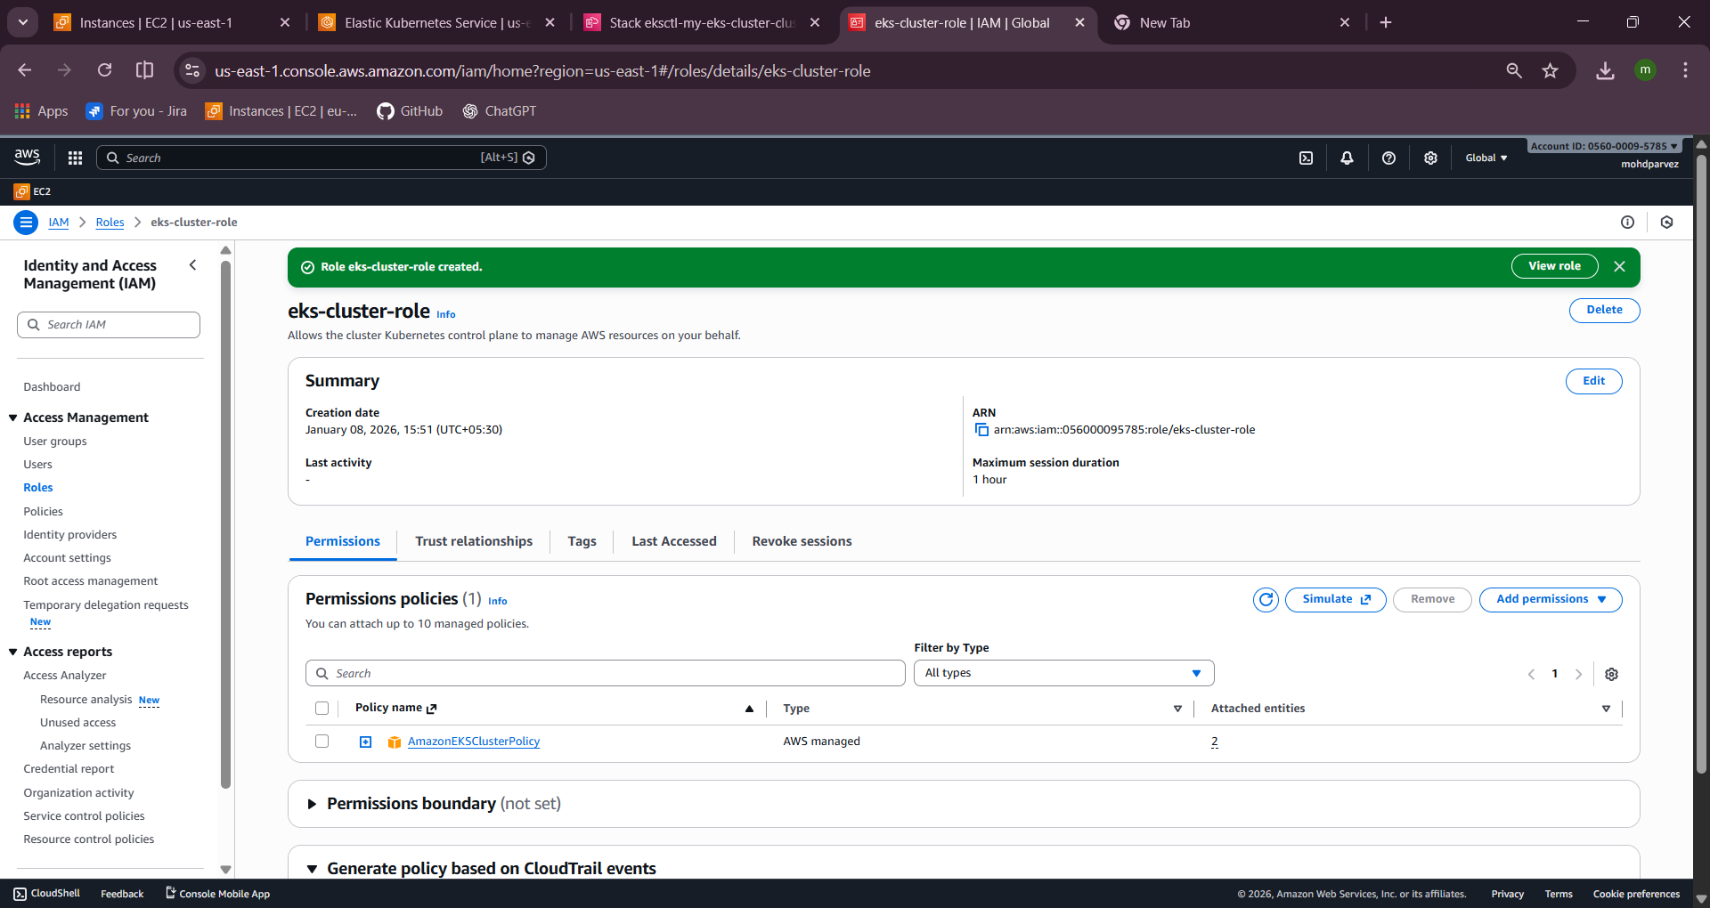

Create an IAM Role for Worker Nodes:
Attach these 3 policies
• AmazonEKSWorkerNodePolicy
• AmazonEKS_CNI_Policy
• AmazonEC2ContainerRegistryReadOnly
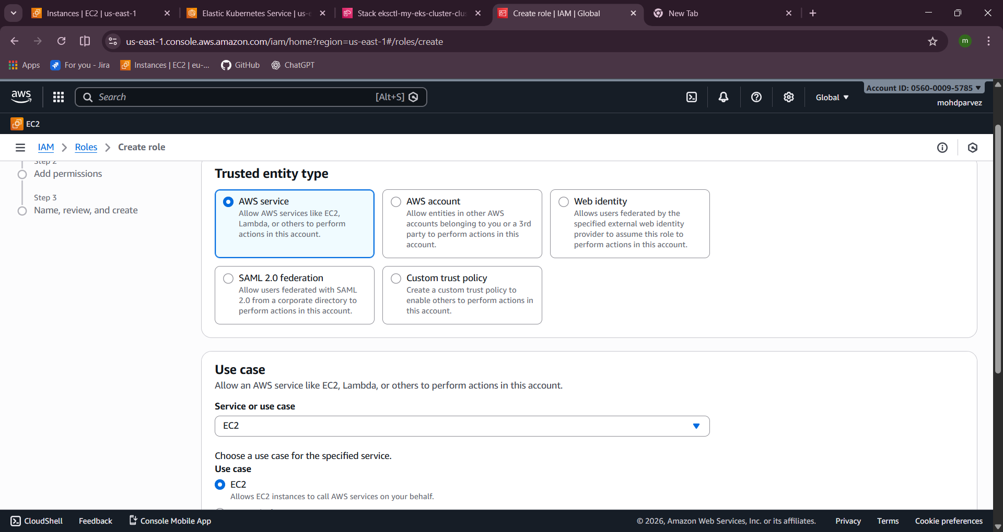
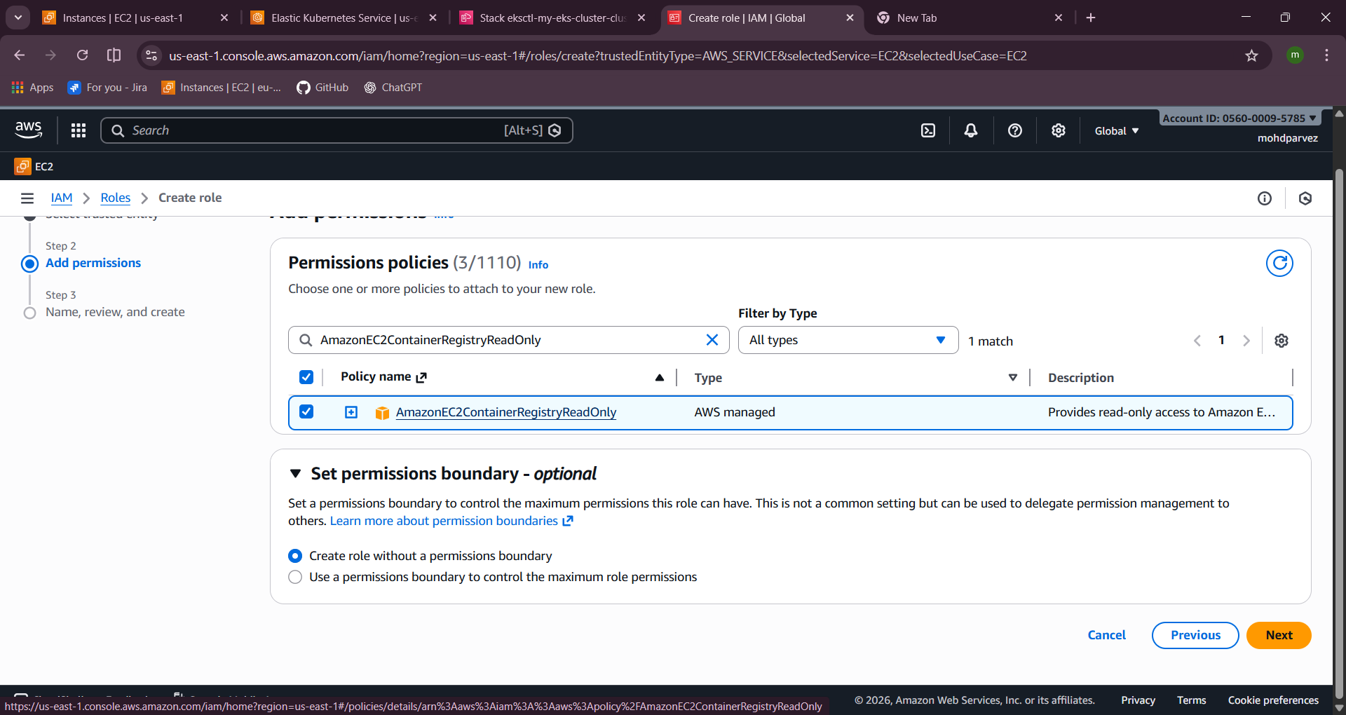
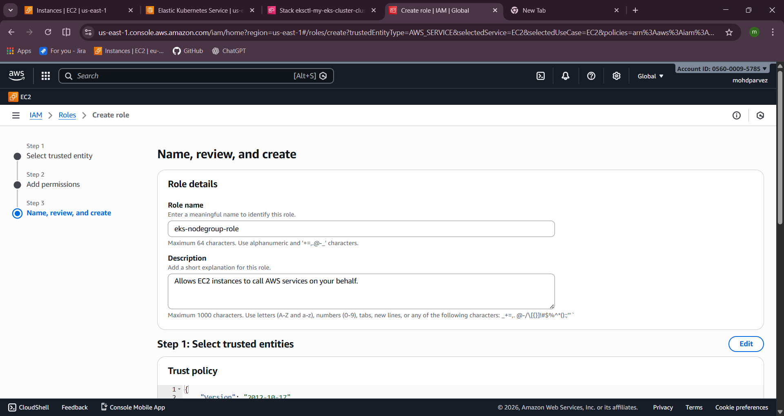
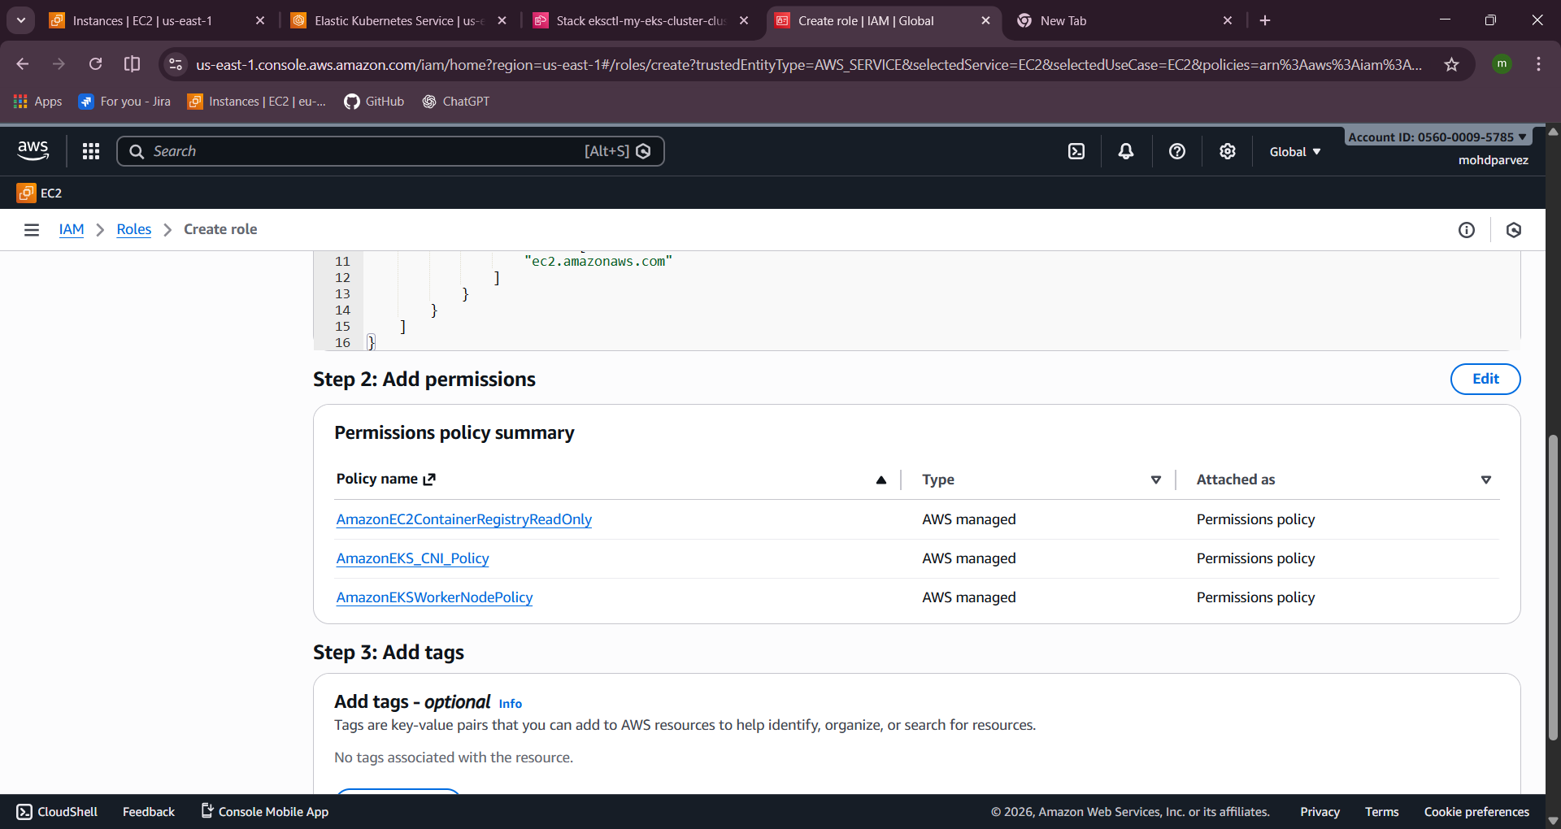
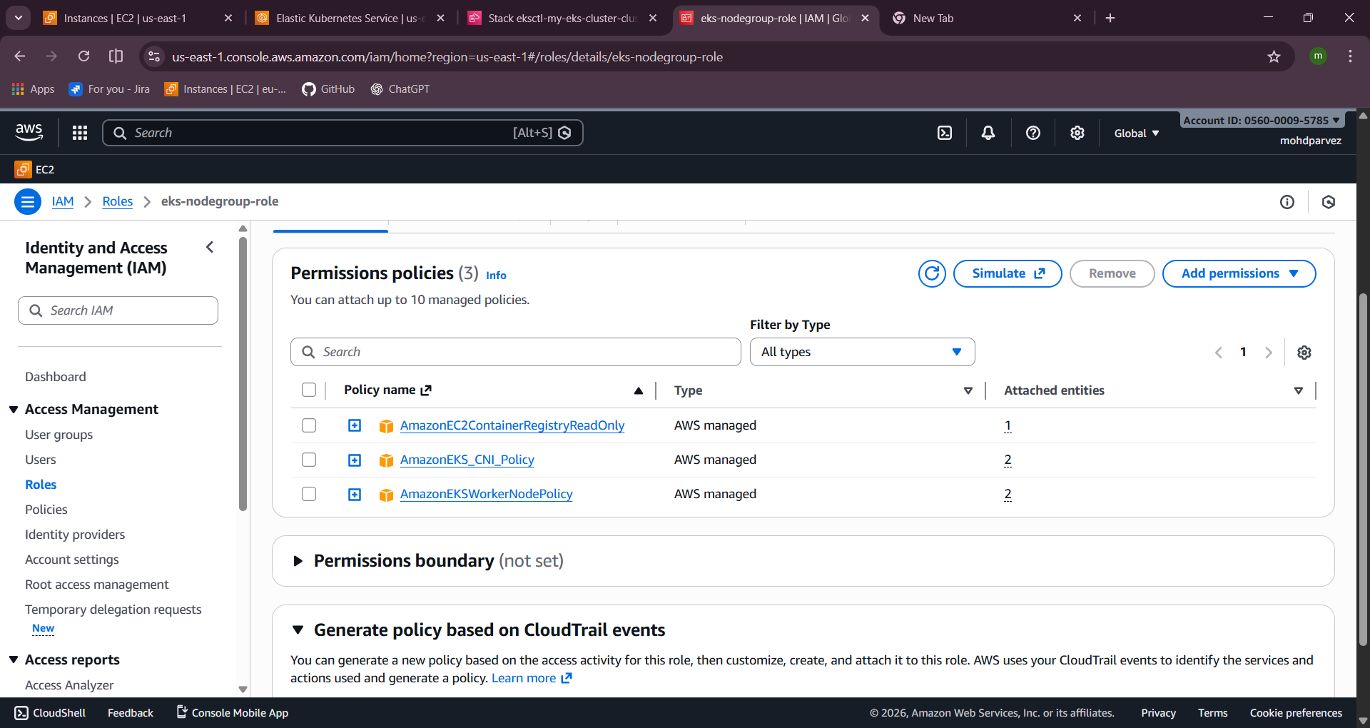 Go to eks and create cluster
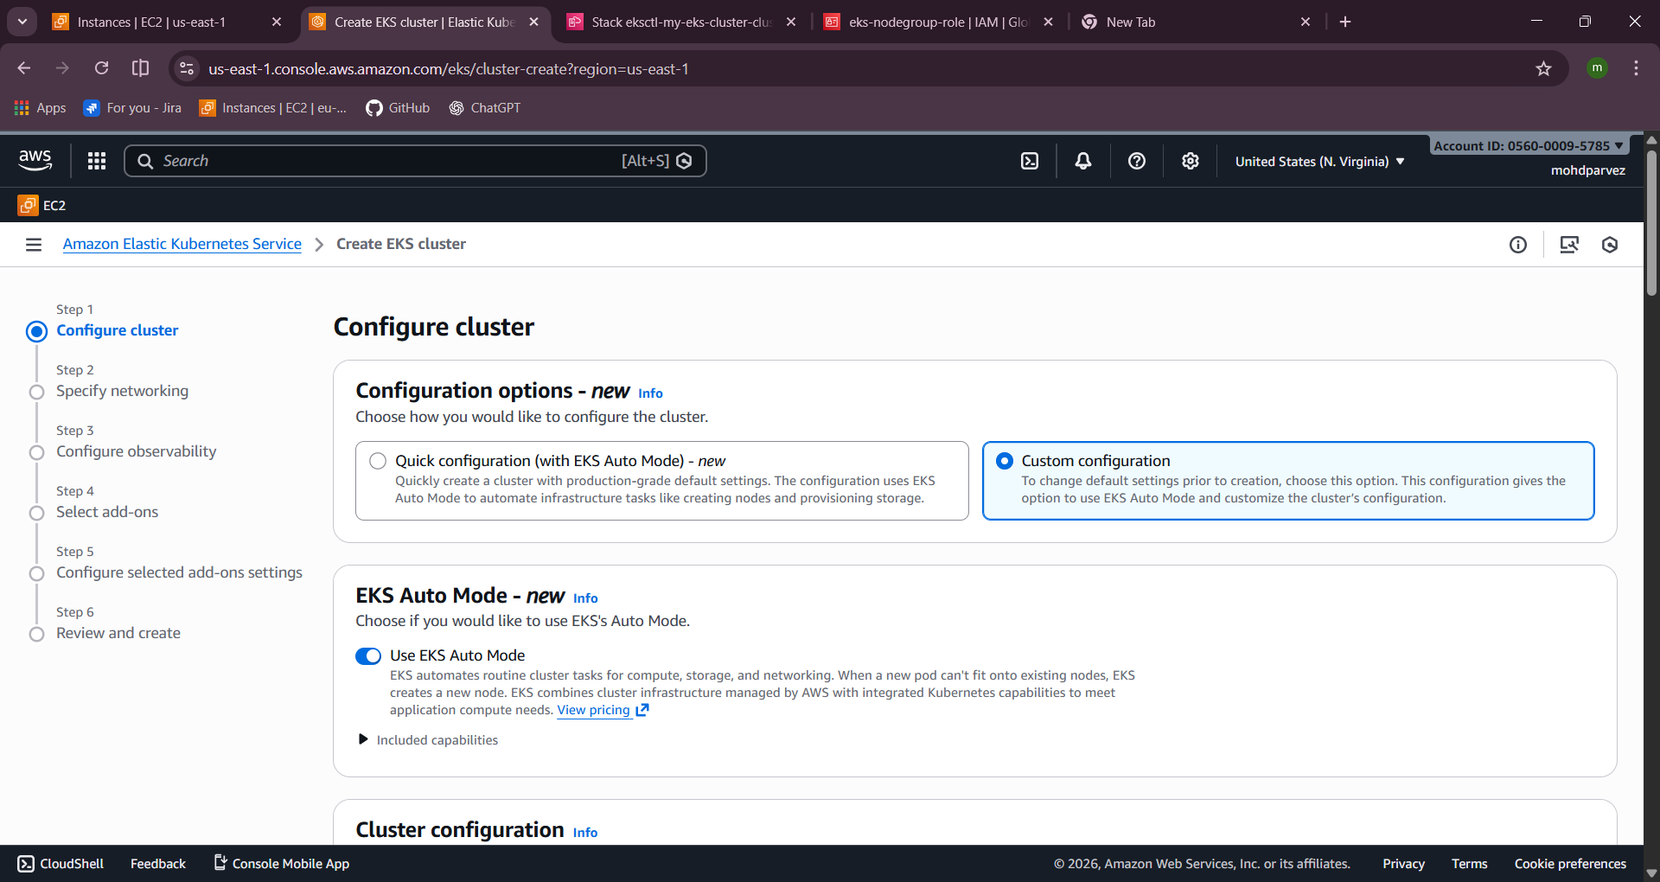
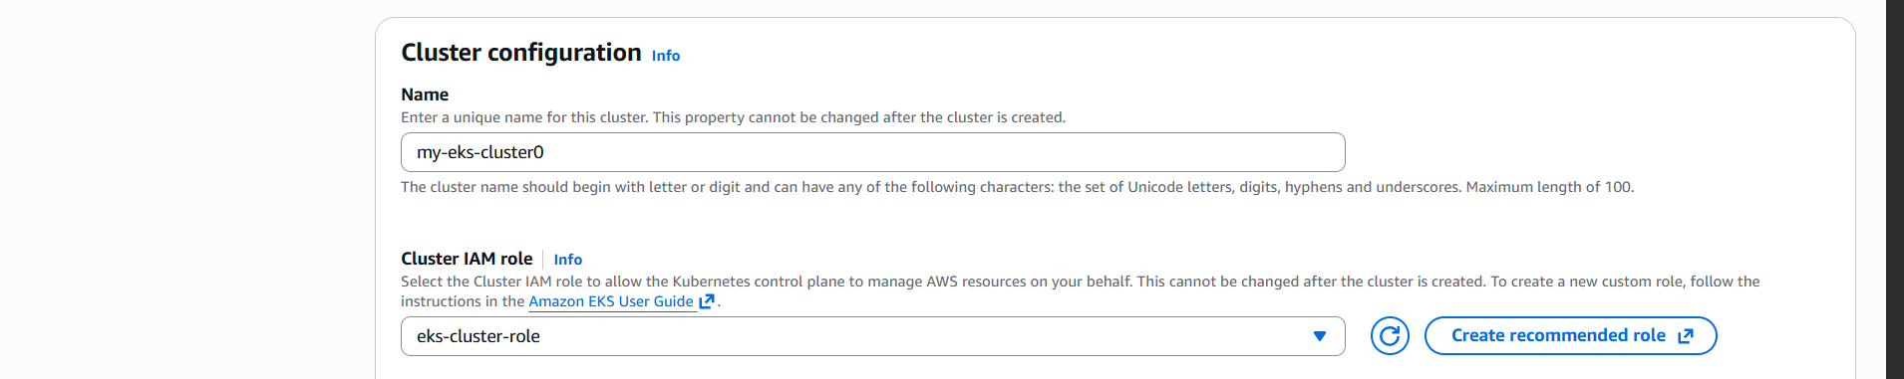
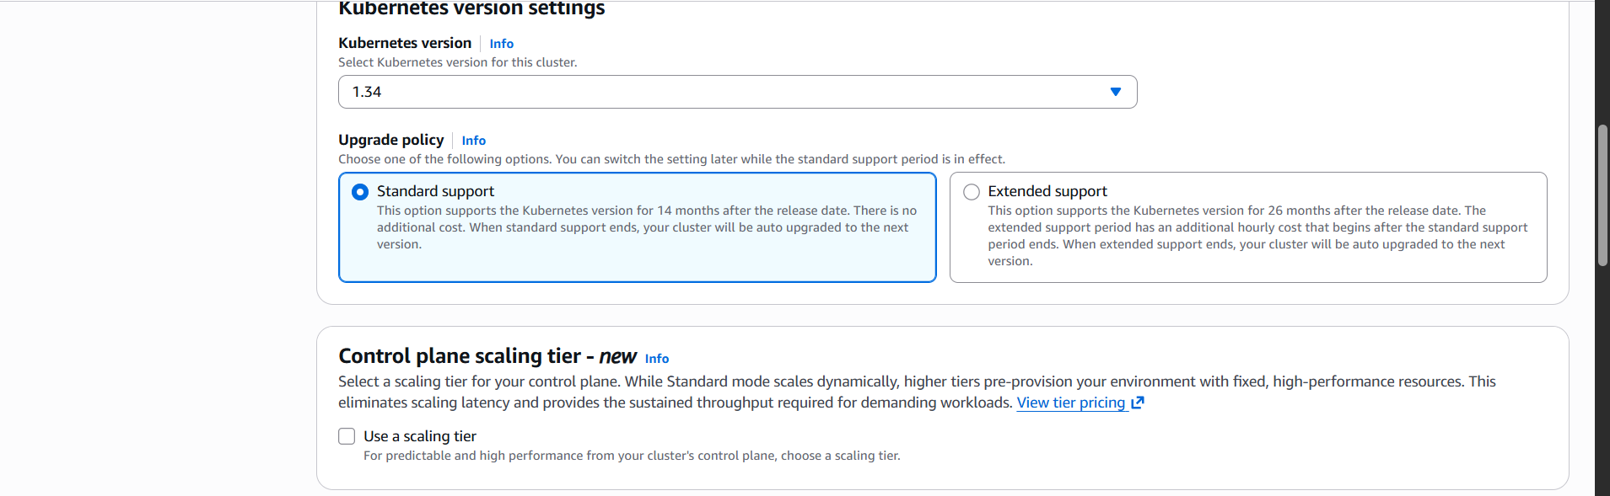
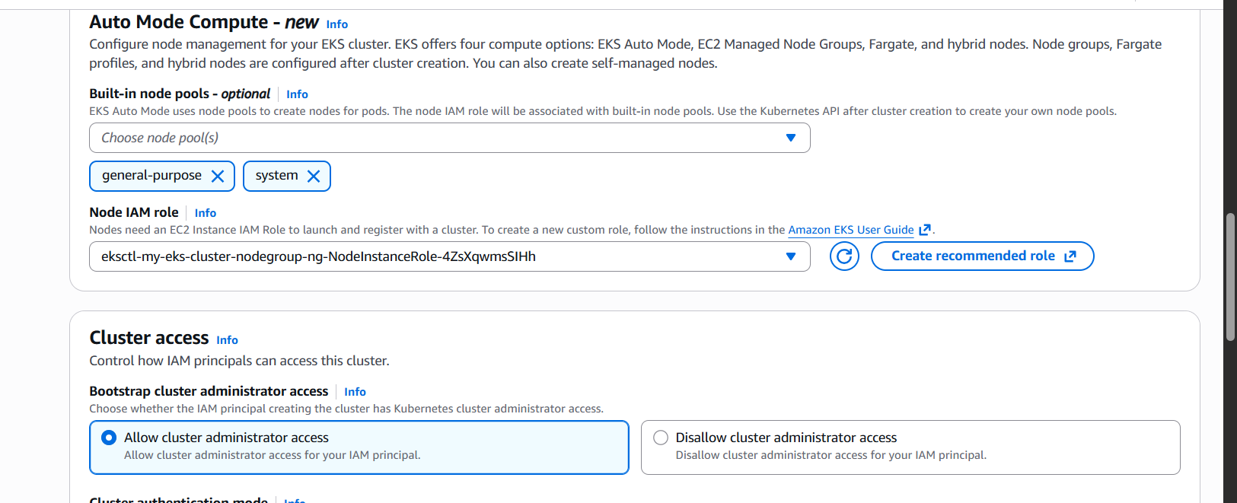

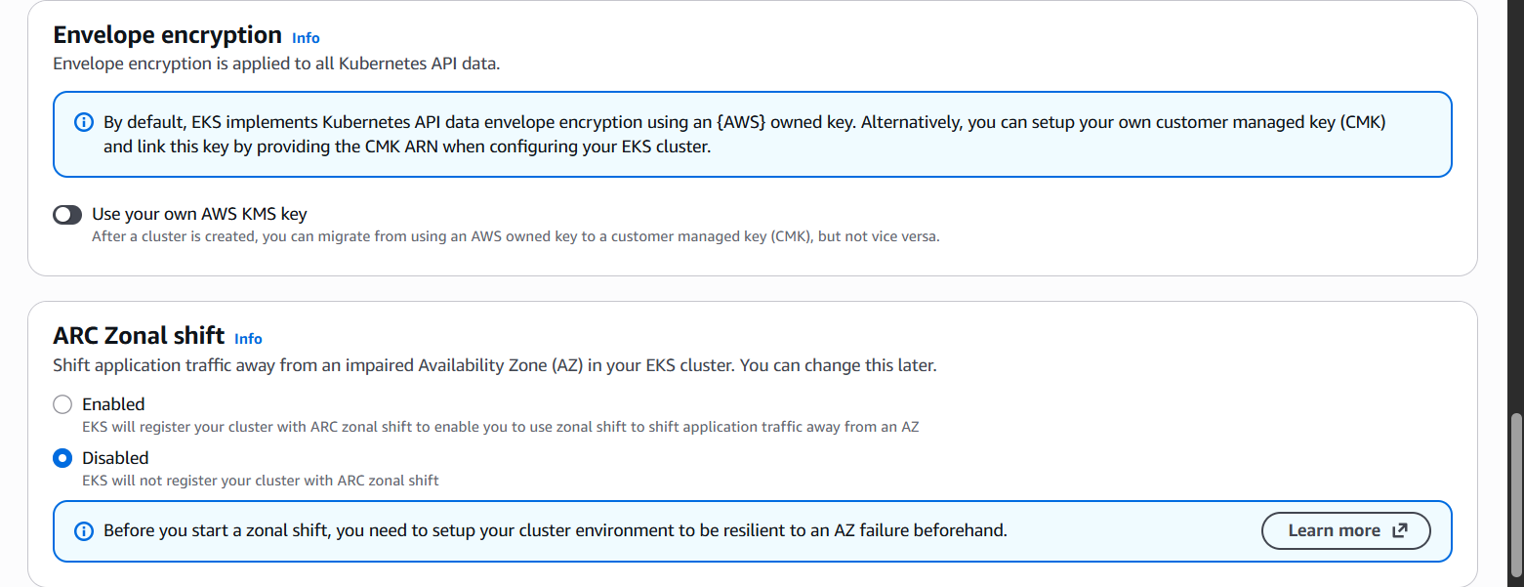
next
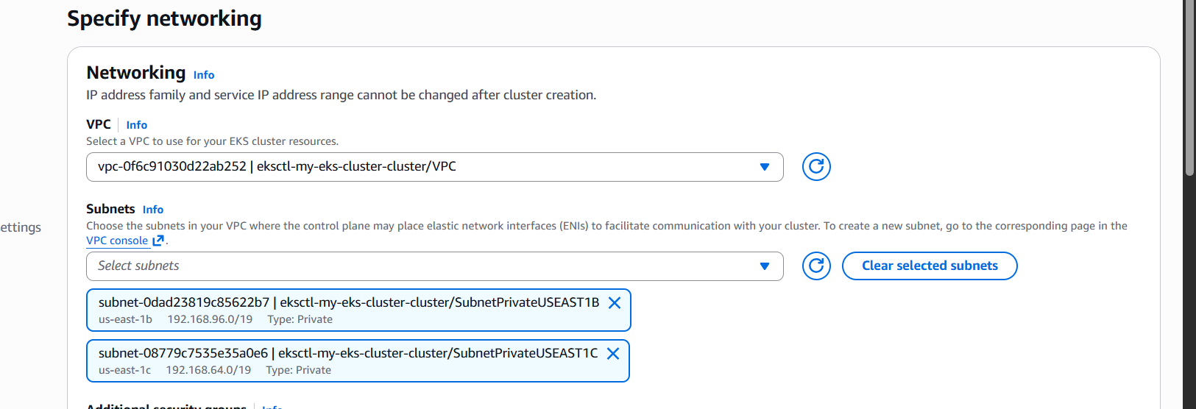
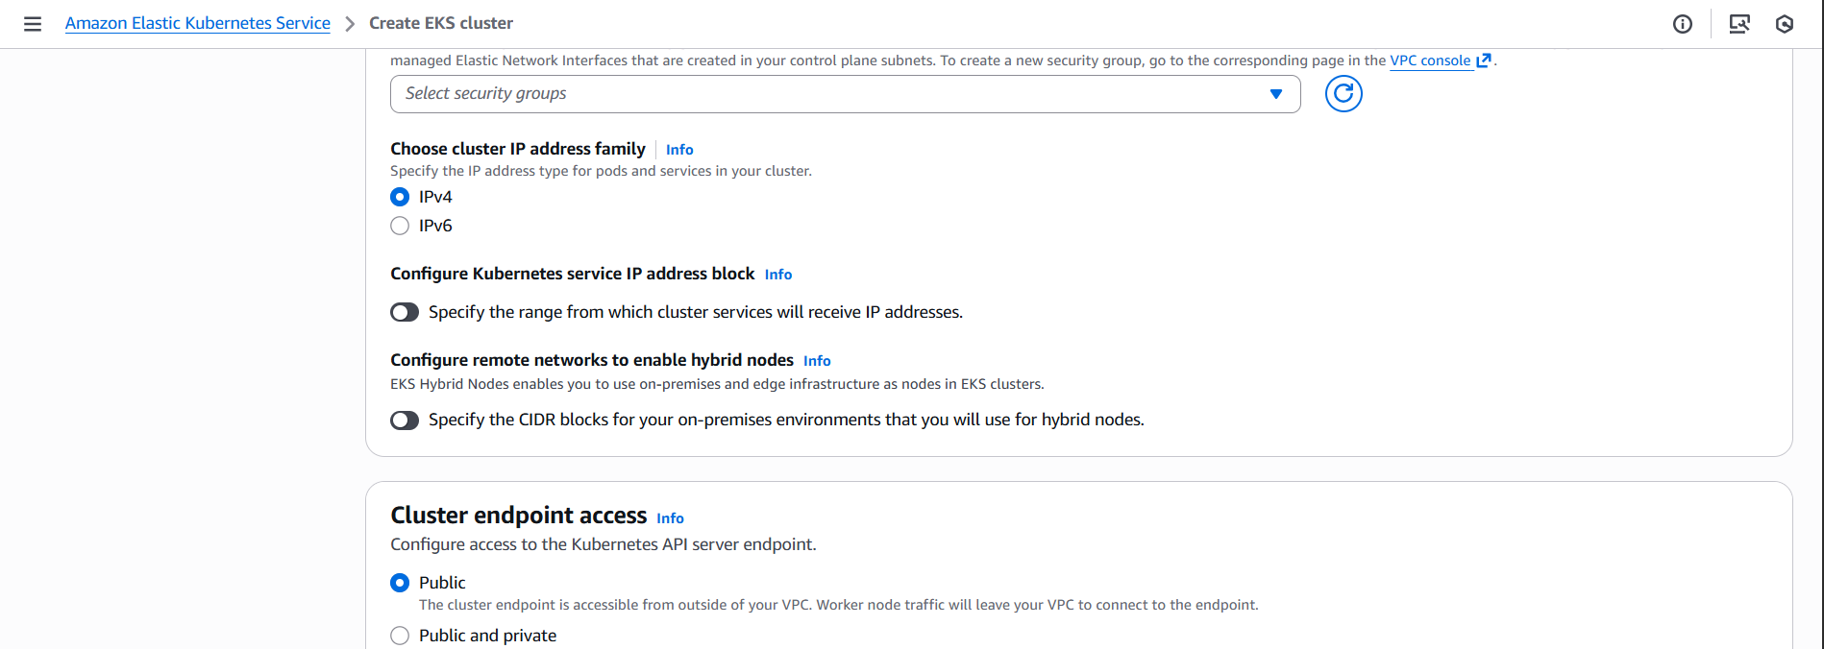
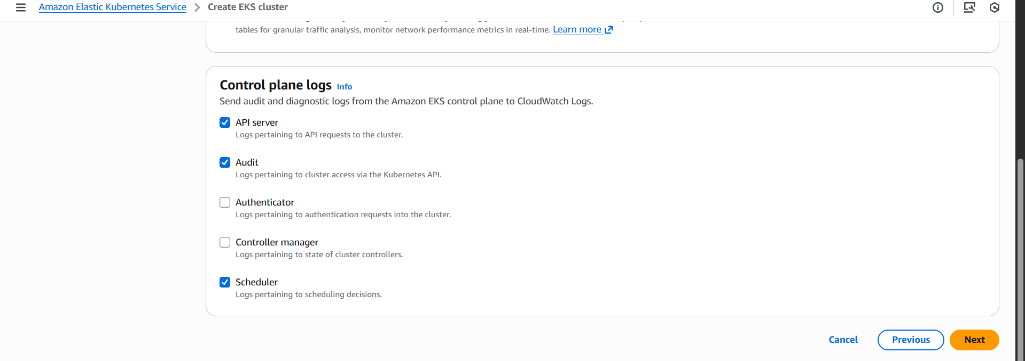
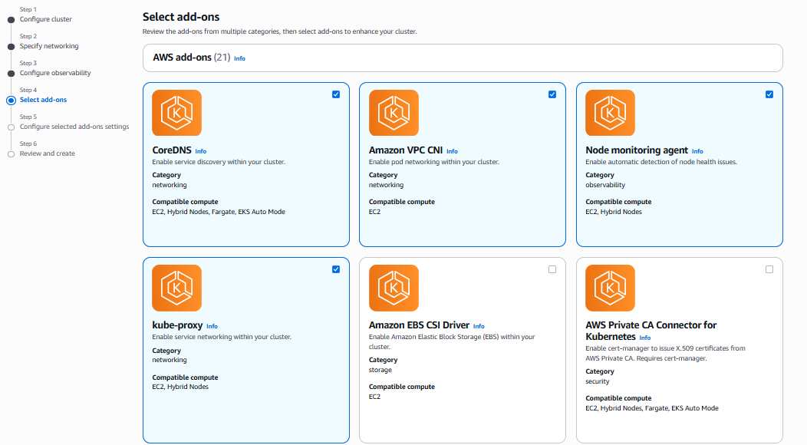
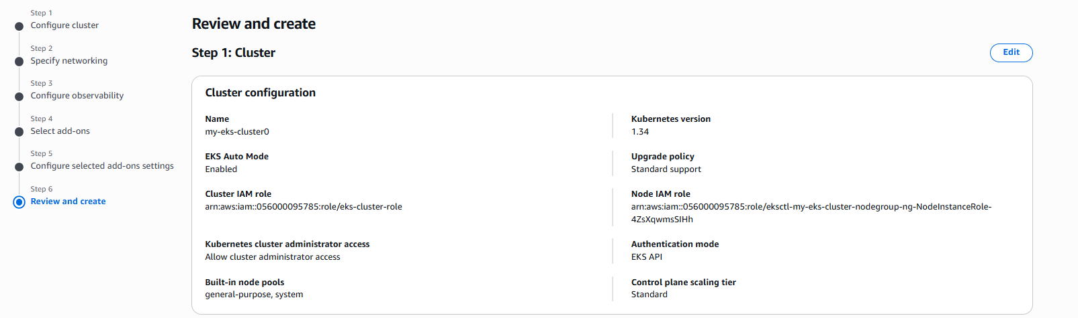
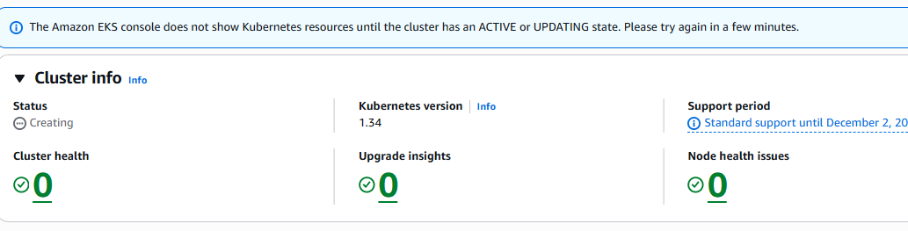
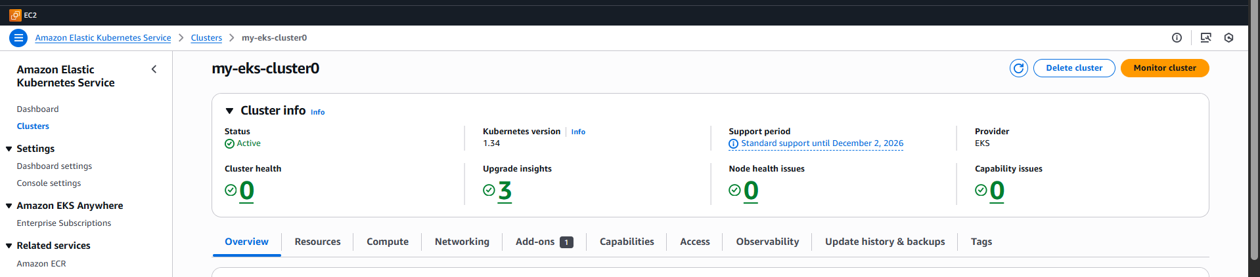

Setup HPA
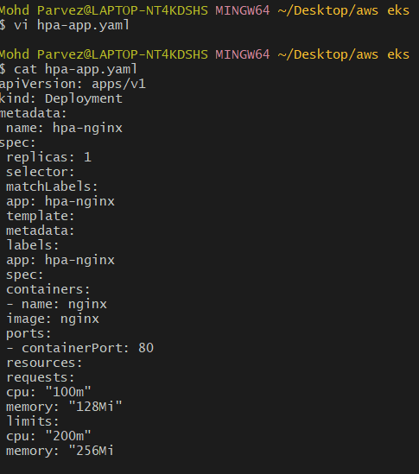
- vi hpa-app.yaml
apiVersion: apps/v1
kind: Deployment
metadata:
name: hpa-nginx
spec:
replicas: 1
selector:
matchLabels:
app: hpa-nginx
template:
metadata:
labels:
app: hpa-nginx
spec:
containers:
- name: nginx
image: nginx
ports:
- containerPort: 80
resources:
requests:
cpu: "100m"
memory: "128Mi"
limits:
cpu: "200m"
memory: "256Mi"
# Kubectl apply -f hpa-app.yaml
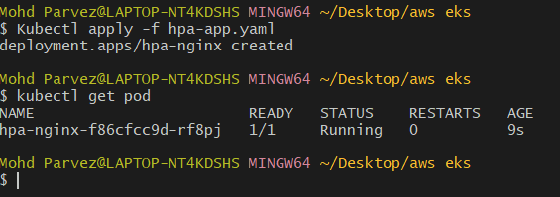

# vi service.yaml

apiVersion: v1
kind: Service
metadata:
name: hpa-nginx-service
spec:
selector:
app: hpa-nginx
ports:
- port: 80
targetPort: 80

# Kubectl apply -f service.yml
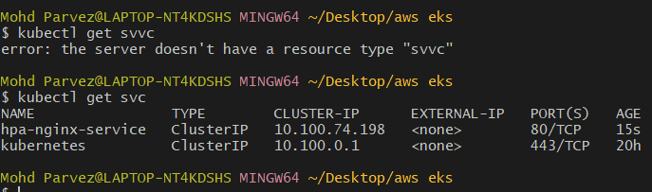

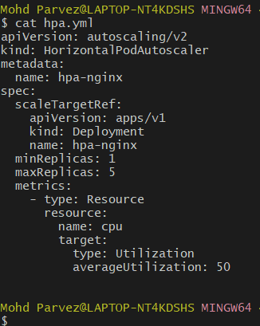
# vi hpa.yaml
apiVersion: autoscaling/v2
kind: HorizontalPodAutoscaler
metadata:
name: hpa-nginx
spec:
scaleTargetRef:
apiVersion: apps/v1
kind: Deployment
name: hpa-nginx
minReplicas: 1
maxReplicas: 5
metrics:
- type: Resource
resource:
name: cpu
target:
type: Utilization
averageUtilization: 5

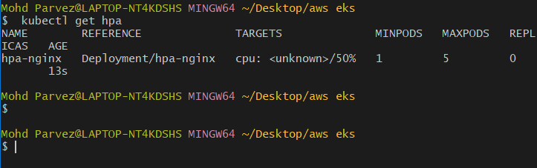

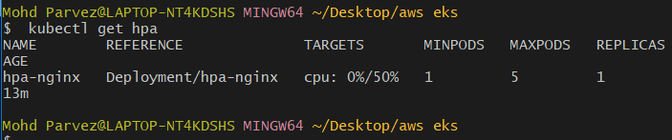

4. Setup cluster autoscale
vi cluster-autoscaler-policy.json
{
"Version": "2012-10-17",
"Statement": [
{
"Effect": "Allow",
"Action": [
"autoscaling:DescribeAutoScalingGroups",
"autoscaling:DescribeAutoScalingInstances",
"autoscaling:DescribeLaunchConfigurations",
"autoscaling:DescribeScalingActivities",
"autoscaling:SetDesiredCapacity",
"autoscaling:TerminateInstanceInAutoScalingGroup",
"ec2:DescribeLaunchTemplateVersions"
],
"Resource": "*"
}
]
}
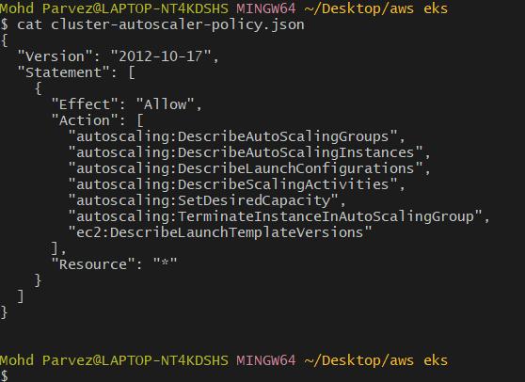
# aws iam create-policy \
--policy-name AmazonEKSClusterAutoscalerPolicy \
--policy-document file://cluster-autoscaler-policy.json
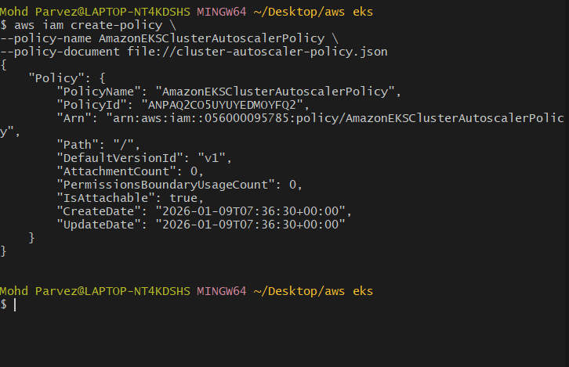

Get OIDC provider:
# eksctl utils associate-iam-oidc-provider \
--region us-east-1 \
--cluster my-eks-cluster \
--approve
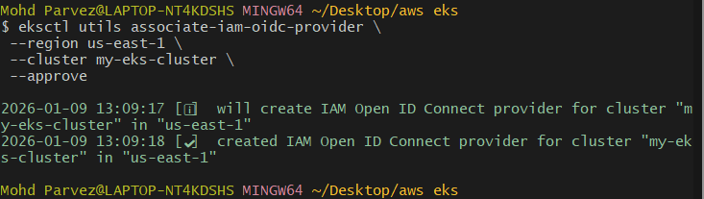
# aws eks describe-cluster \
--name my-eks-cluster \
--query "cluster.identity.oidc.issuer" \
--output text
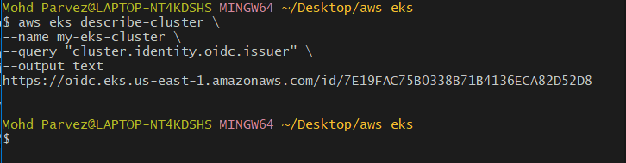

# eksctl create iamserviceaccount \
--name cluster-autoscaler \
--namespace kube-system \
--cluster my-eks-cluster \
--attach-policy-arn arn:aws:iam::235351028455:policy/AmazonEKSClusterAutoscalerPolicy \
--approve \
--override-existing-serviceaccounts
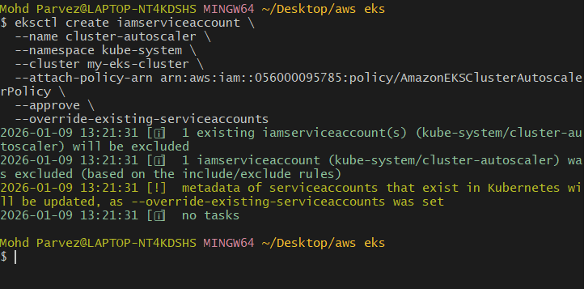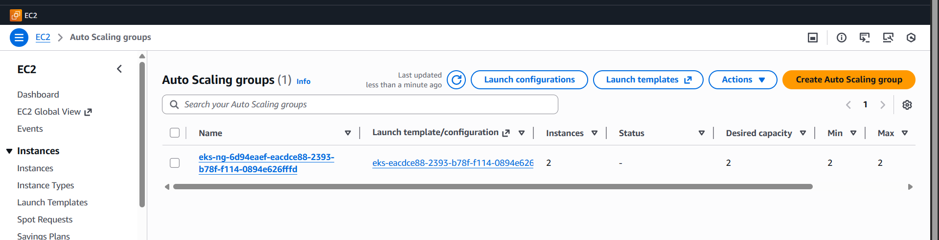
# kubectl create sa cluster-autoscaler -n kube-system
# kubectl get sa cluster-autoscaler -n kube-system
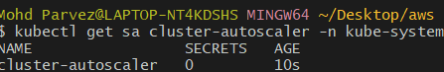

Create a new file:
# vi cluster-autoscaler.yaml
apiVersion: apps/v1
kind: Deployment
metadata:
name: cluster-autoscaler
namespace: kube-system
spec:
replicas: 1
selector:
matchLabels:
app: cluster-autoscaler
template:
metadata:
labels:
app: cluster-autoscaler
annotations:
cluster-autoscaler.kubernetes.io/safe-to-evict: "false"
spec:
serviceAccountName: cluster-autoscaler
tolerations:
- key: "node-role.kubernetes.io/control-plane"
operator: "Exists"
effect: "NoSchedule"
- key: "node-role.kubernetes.io/master"
operator: "Exists"
effect: "NoSchedule"
- key: "CriticalAddonsOnly"
operator: "Exists"
containers:
- name: cluster-autoscaler
image: registry.k8s.io/autoscaling/cluster-autoscaler:v1.29.0
command:
- ./cluster-autoscaler
- --cloud-provider=aws
- --balance-similar-node-groups
- --skip-nodes-with-system-pods=false
- --skip-nodes-with-local-storage=false
- --nodes=1:5:eks-ng-aaecd7bf-eacdcbed-0941-9e78-69f7-95cf5029d0af
- --stderrthreshold=info
- --v=4
resources:
requests:
cpu: 100m
memory: 300Mi
limits:
cpu: 100m
memory: 300Mi
Save and exit.
Apply the new deployment
kubectl apply -f cluster-autoscaler.yaml
Verify
kubectl get deployments -n kube-system
kubectl get pods -n kube-system | grep autoscaler

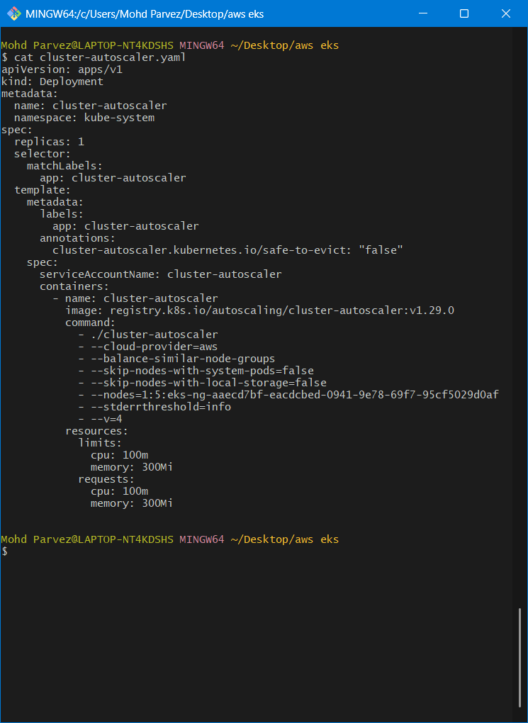

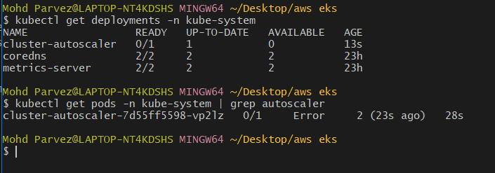

Create a file:
vi cluster-autoscaler-rbac.yaml
###Paste
apiVersion: rbac.authorization.k8s.io/v1
kind: ClusterRole
metadata:
name: cluster-autoscaler
rules:
- apiGroups: [""]
resources: ["events", "endpoints"]
verbs: ["create", "patch"]

- apiGroups: [""]
resources: ["pods/eviction"]
verbs: ["create"]

- apiGroups: [""]
resources: ["pods/status"]
verbs: ["update"]

- apiGroups: [""]
resources: ["endpoints"]
resourceNames: ["cluster-autoscaler"]
verbs: ["get", "update"]

- apiGroups: [""]
resources: ["nodes"]
verbs: ["watch", "list", "get", "update"]

- apiGroups: [""]
resources:
- pods
- services
- replicationcontrollers
- persistentvolumeclaims
verbs: ["watch", "list", "get"]

- apiGroups: ["apps"]
resources: ["replicasets", "daemonsets", "deployments"]
verbs: ["watch", "list", "get"]

- apiGroups: ["extensions"]
resources: ["replicasets", "deployments"]
verbs: ["watch", "list", "get"]

- apiGroups: ["policy"]
resources: ["poddisruptionbudgets"]
verbs: ["watch", "list"]
- apiGroups: ["coordination.k8s.io"]
resources: ["leases"]
verbs: ["get", "watch", "list", "create", "update", "patch"]
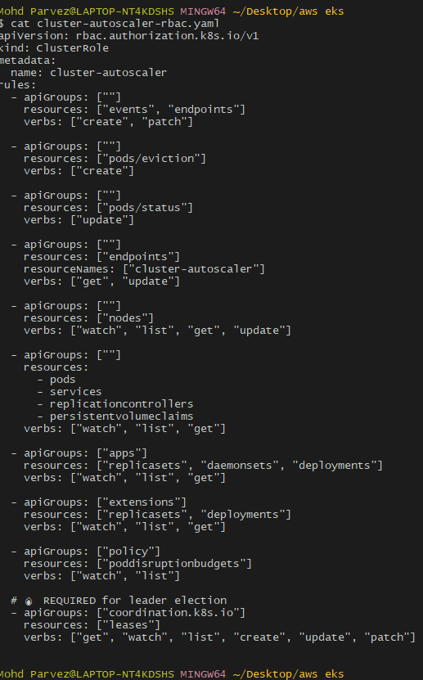
# kubectl apply -f cluster-autoscaler-rbac.yaml

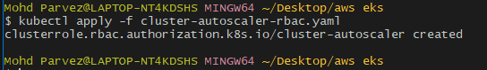
Create ClusterRoleBinding (REQUIRED)
Create another file:
# vi cluster-autoscaler-rbac-binding.yaml
### Paste this
apiVersion: rbac.authorization.k8s.io/v1
kind: ClusterRoleBinding
metadata:
name: cluster-autoscaler
subjects:
- kind: ServiceAccount
name: cluster-autoscaler
namespace: kube-system
roleRef:
kind: ClusterRole
name: cluster-autoscaler
apiGroup: rbac.authorization.k8s.io
Save and exit.
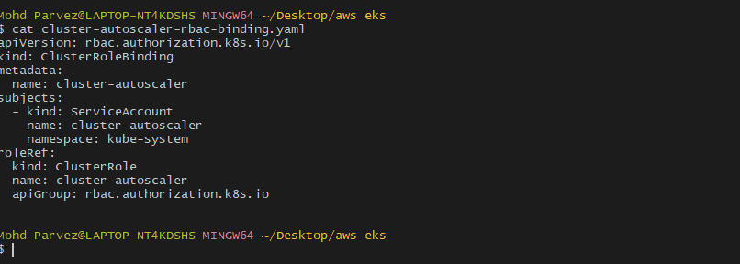

Apply RBAC
kubectl apply -f cluster-autoscaler-rbac-binding.yaml

Restart Cluster Autoscaler
kubectl rollout restart deployment cluster-autoscaler -n kube-system
Create CORRECT Deployment

Create file:
vi cluster-autoscaler.yaml
Paste:

apiVersion: apps/v1
kind: Deployment
metadata:
name: cluster-autoscaler
namespace: kube-system
spec:
replicas: 1
selector:
matchLabels:
app: cluster-autoscaler
template:
metadata:
labels:
app: cluster-autoscaler
annotations:
cluster-autoscaler.kubernetes.io/safe-to-evict: "false"
spec:
serviceAccountName: cluster-autoscaler
tolerations:
- key: "node-role.kubernetes.io/control-plane"
operator: "Exists"
effect: "NoSchedule"
- key: "node-role.kubernetes.io/master"
operator: "Exists"
effect: "NoSchedule"
- key: "CriticalAddonsOnly"
operator: "Exists"
containers:
- name: cluster-autoscaler
image: registry.k8s.io/autoscaling/cluster-autoscaler:v1.29.0
command:
- ./cluster-autoscaler
- --cloud-provider=aws
- --balance-similar-node-groups
- --skip-nodes-with-system-pods=false
- --skip-nodes-with-local-storage=false
- --node-group-auto-discovery=asg:tag=k8s.io/cluster-autoscaler/enabled,k8s.io/cluster-autoscaler/my-eks-cluster
- --stderrthreshold=info
- --v=4
resources:
requests:
cpu: 100m
memory: 300Mi
limits:
cpu: 100m
memory: 300Mi limits:
cpu: 100m
memory: 300Mi

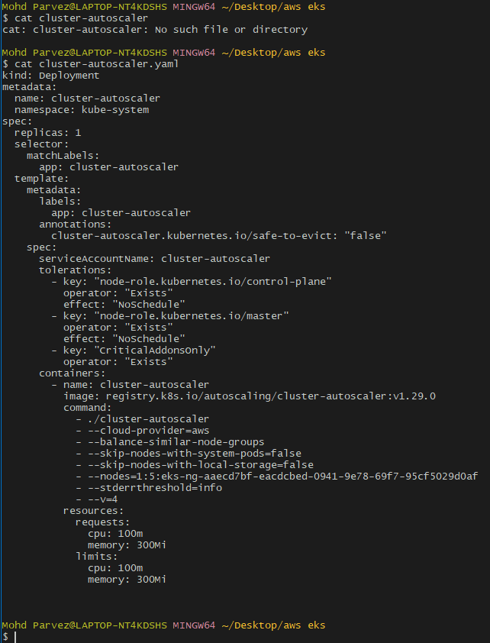
Apply:

kubectl apply -f cluster-autoscaler.yaml

✅ STEP 6: Verify (this MUST succeed now)
kubectl get pods -n kube-system | grep autoscaler

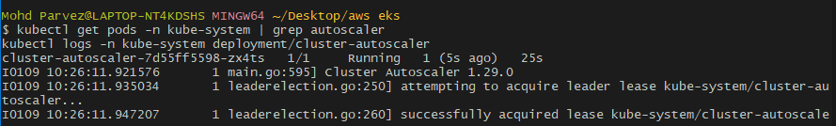

Check logs:

kubectl logs -n kube-system deployment/cluster-autoscaler
kubectl apply -f test-pod.yaml
kubectl describe pod cpu-stress
kubectl get nodes -w
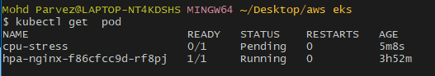

5. Setup cronjob and job
# vi job.yaml
apiVersion: batch/v1
kind: Job
metadata:
name: sample-job
spec:
backoffLimit: 3
completions: 1
parallelism: 1
template:
spec:
restartPolicy: Never
containers:
- name: job-container
image: busybox
command:
- sh
- -c
- |
echo "Job started"
sleep 10
echo "Job completed"

# kubectl apply -f job.yaml
# kubectl get jobs
# kubectl logs job/sample-job
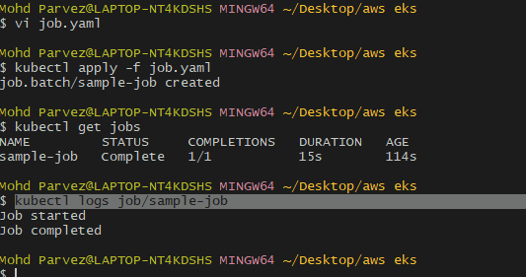

Create secret and inject inside pod
kubectl create secret generic app-secret \
--from-literal=DB_USER=admin \
--from-literal=DB_PASSWORD=admin123
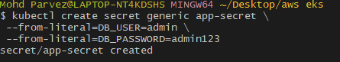
kubectl get secret app-secret
kubectl describe secret app-secret
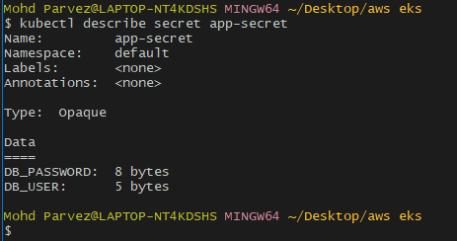
# vi secret-env-pod.yaml
apiVersion: v1
kind: Pod
metadata:
name: secret-env-pod
spec:
containers:
- name: test-container
image: busybox
command: ["sh", "-c", "env | grep DB && sleep 3600"]
env:
- name: DB_USER
valueFrom:
secretKeyRef:
name: app-secret
key: DB_USER
- name: DB_PASSWORD
valueFrom:
secretKeyRef:
name: app-secret
key: DB_PASSWORD

# kubectl apply -f secret-env-pod.yaml
# kubectl logs secret-env-pod
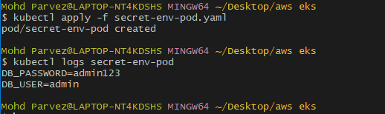
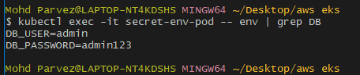

7.Check different add-o Amazon VPC CNI
• CoreDNS
• kube-proxy
• Amazon EBS CSI Driver
• Metrics Server
• Amazon EFS CSI Driver
• AWS Load Balancer Controller
• Amazon GuardDuty Agent
• Amazon CloudWatch Observability
• Amazon VPC Lattice Controllerns available on eks.
• Amazon VPC CNI
• CoreDNS
• kube-proxy
• Amazon EBS CSI Driver
• Metrics Server
• Amazon EFS CSI Driver
• AWS Load Balancer Controller
• Amazon GuardDuty Agent
• Amazon CloudWatch Observability
• Amazon VPC Lattice Controller
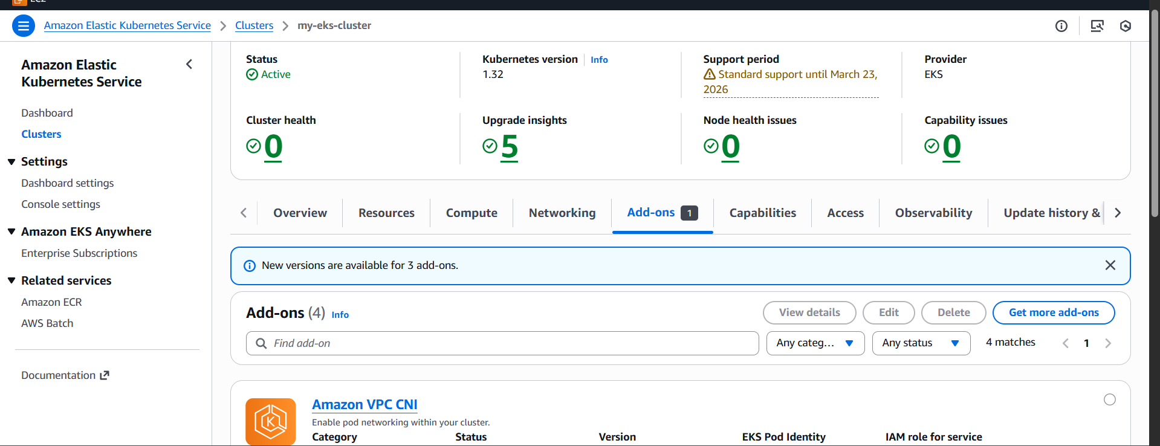
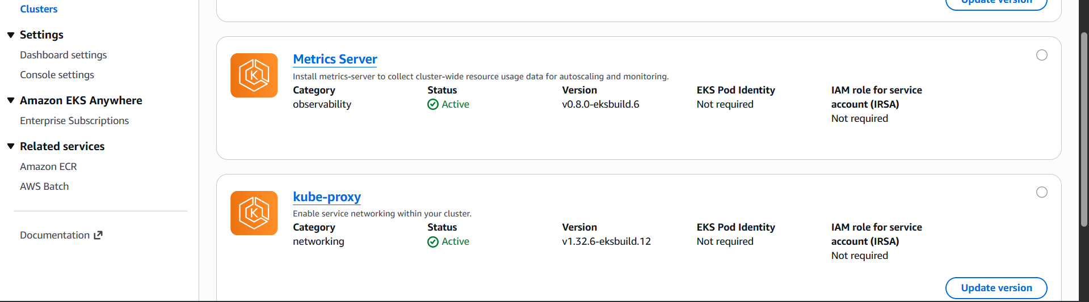
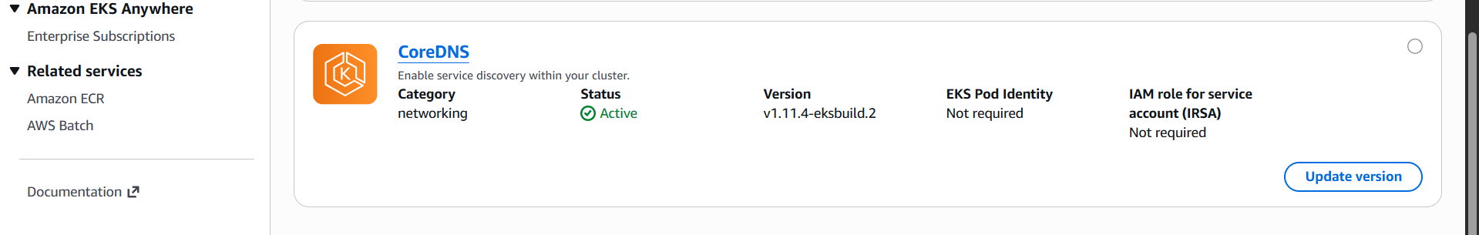

8. Upgrade eks cluster
aws eks describe-cluster \
--name my-eks-cluster \
--query cluster.version
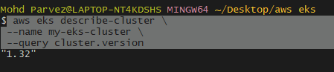
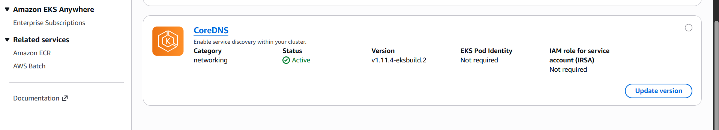
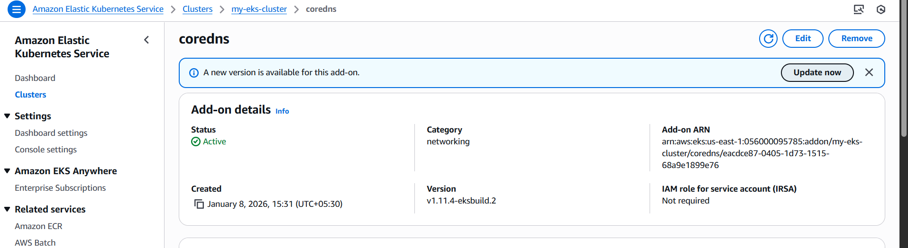
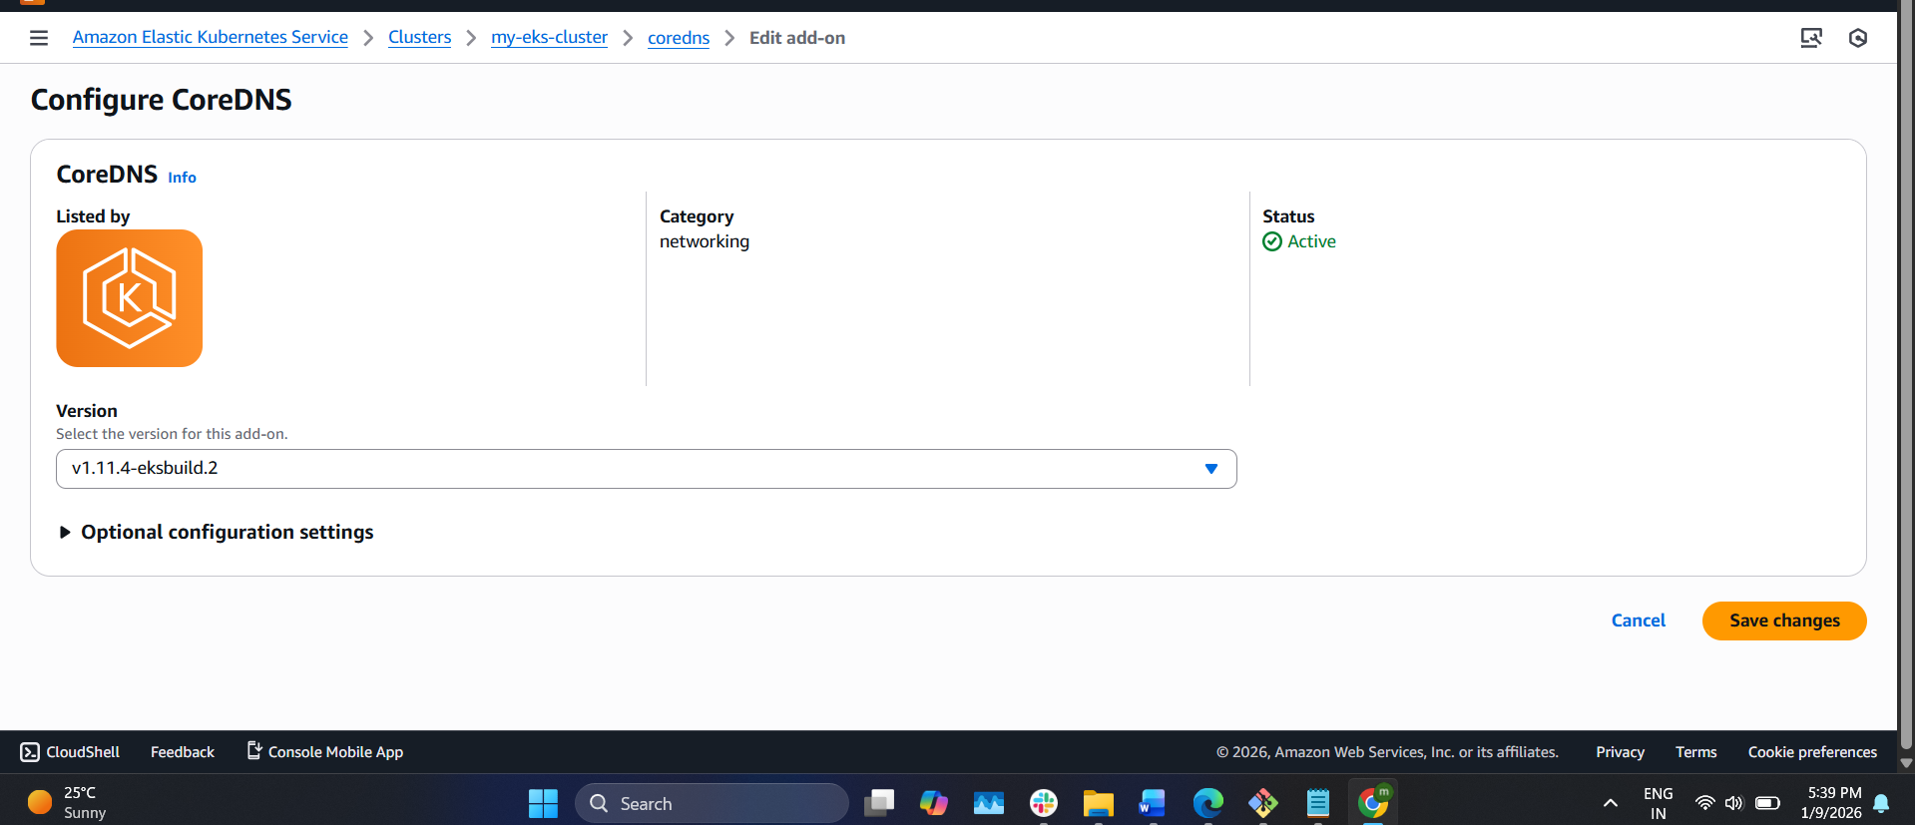
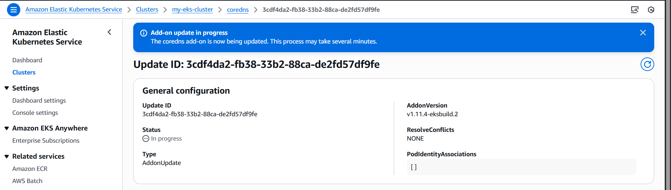
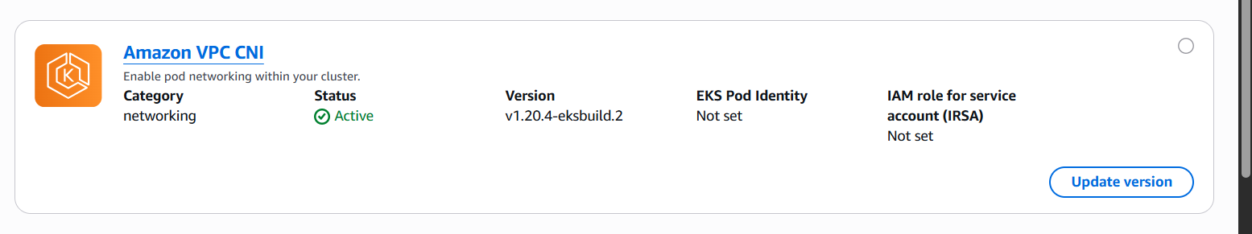
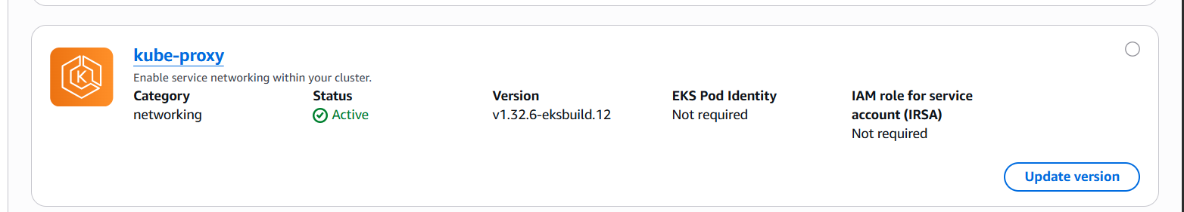
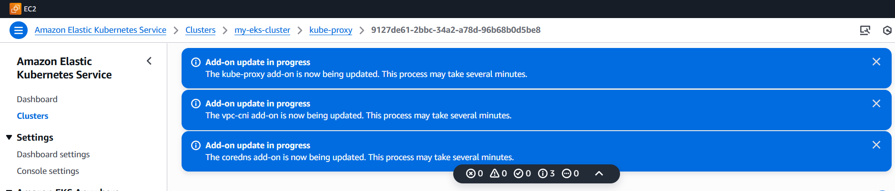
Upgrade kubectl:
curl -LO https://dl.k8s.io/release/v1.32.0/bin/windows/amd64 /kubectl.exe
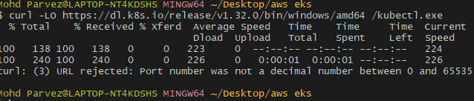
# mv kubectl.exe /c/Windows/System32/kubectl.exe
# kubectl version
